Data Science

1. Write program to check whether number is Harshad number or Not.

A **Harshad number** (or Niven number) is an integer that is divisible by the sum of its digits. Here's a Python program to check whether a given number is a Harshad number:

```python

def is_harshad_number(num):

if num <= 0:

return False # Harshad numbers are positive integers

# Calculate the sum of the digits

digit_sum = sum(int(digit) for digit in str(num))

# Check if the number is divisible by the sum of its digits

return num % digit_sum == 0

# Input from user

number = int(input("Enter a number: "))

# Check and display the result

if is_harshad_number(number):

print(f"{number} is a Harshad number.")

else:

print(f"{number} is not a Harshad number.")

```

1. Implement clustering algorithm on given “income.csv” dataset and display it using scatter plot on given iris dataset.

### Implementation

Below is the Python code to achieve this:

```python

import pandas as pd

import numpy as np

from sklearn.cluster import KMeans

from sklearn.datasets import load_iris

import matplotlib.pyplot as plt

from sklearn.preprocessing import StandardScaler

# Load the income.csv dataset

income_data = pd.read_csv("income.csv")

# Assuming 'income.csv' has numerical features like 'Income' and 'Spending_Score'

# Normalize the data

scaler = StandardScaler()

normalized_income_data = scaler.fit_transform(income_data.select_dtypes(include=[np.number]))

# Apply k-means clustering

kmeans = KMeans(n_clusters=3, random_state=42)

income_clusters = kmeans.fit_predict(normalized_income_data)

# Load the Iris dataset

iris = load_iris()

iris_data = iris.data

iris_features = iris.feature_names

# Take the first two features for plotting

x = iris_data[:, 0] # Sepal Length

y = iris_data[:, 1] # Sepal Width

# Scatter plot

plt.figure(figsize=(10, 6))

plt.scatter(x, y, c=income_clusters, cmap='viridis', s=50)

plt.title("Clustering from Income Dataset Visualized on Iris Dataset")

plt.xlabel(iris_features[0])

plt.ylabel(iris_features[1])

plt.colorbar(label='Cluster Label')

plt.show()

```

1. Write a python program to count the occurrence of each word in a given sentence

def count_word_occurrences(sentence):

# Convert the sentence to lowercase and split into words

words = sentence.lower().split()

# Create a dictionary to store word counts

word_counts = {}

for word in words:

# Remove punctuation from words

word = ''.join(char for char in word if char.isalnum())

# Increment the count of the word in the dictionary

if word in word_counts:

word_counts[word] += 1

else:

word_counts[word] = 1

return word_counts

# Input sentence from the user

sentence = input("Enter a sentence: ")

# Get the word occurrences

occurrences = count_word_occurrences(sentence)

# Display the results

print("Word occurrences:")

for word, count in occurrences.items():

print(f"{word}: {count}")

4. Implement clustering algorithm on given “income.csv” dataset and display it using scatter plot.

import pandas as pd

import numpy as np

from sklearn.cluster import KMeans

from sklearn.preprocessing import StandardScaler

import matplotlib.pyplot as plt

# Load the income.csv dataset

# Replace 'income.csv' with the path to your dataset

data = pd.read_csv("income.csv")

# Inspect the first few rows of the dataset

print("Dataset Head:")

print(data.head())

# Select numerical columns (e.g., 'Income', 'Age')

# Replace these column names with appropriate ones from your dataset

numerical_features = ['Income', 'Spending_Score']

income_data = data[numerical_features]

# Handle missing values if necessary

income_data = income_data.dropna()

# Standardize the data

scaler = StandardScaler()

income_data_scaled = scaler.fit_transform(income_data)

# Apply k-means clustering

kmeans = KMeans(n_clusters=3, random_state=42)

clusters = kmeans.fit_predict(income_data_scaled)

# Add cluster labels to the original data

data['Cluster'] = clusters

# Scatter plot of the clusters

plt.figure(figsize=(10, 6))

plt.scatter(

income_data_scaled[:, 0], income_data_scaled[:, 1],

c=clusters, cmap='viridis', s=50

)

plt.title("Clustering of Income Dataset")

plt.xlabel("Income (Standardized)")

plt.ylabel("Spending Score (Standardized)")

plt.colorbar(label="Cluster")

plt.show()

5. Write a python program to accept input string from user and display number of vowels and consonant in string.

def count_vowels_and_consonants(input_string):

# Define vowels

vowels = "aeiou"

# Initialize counters

vowel_count = 0

consonant_count = 0

# Convert the string to lowercase for uniformity

input_string = input_string.lower()

# Loop through each character in the string

for char in input_string:

if char.isalpha(): # Check if the character is a letter

if char in vowels:

vowel_count += 1

else:

consonant_count += 1

return vowel_count, consonant_count

# Input string from the user

user_input = input("Enter a string: ")

# Get counts

vowels, consonants = count_vowels_and_consonants(user_input)

# Display the results

print(f"Number of vowels: {vowels}")

print(f"Number of consonants: {consonants}")

6.Implement Data Visualization Kindly refers your own data.

1. Draw scatter plot diagram.

2. Draw Histogram.

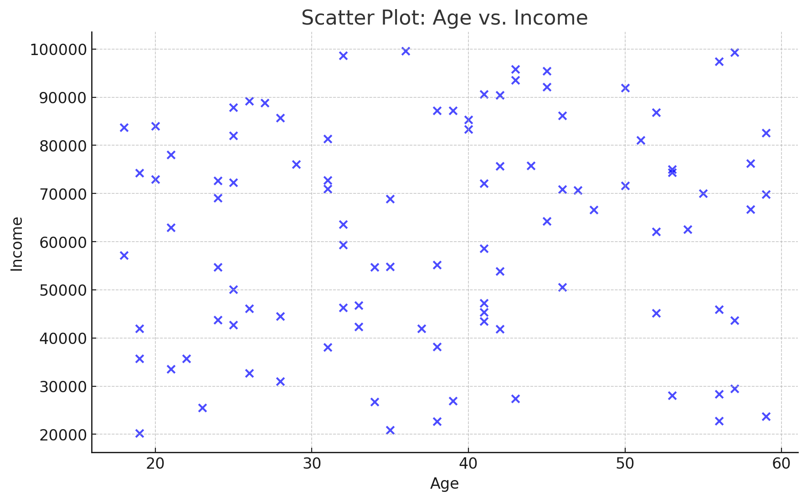

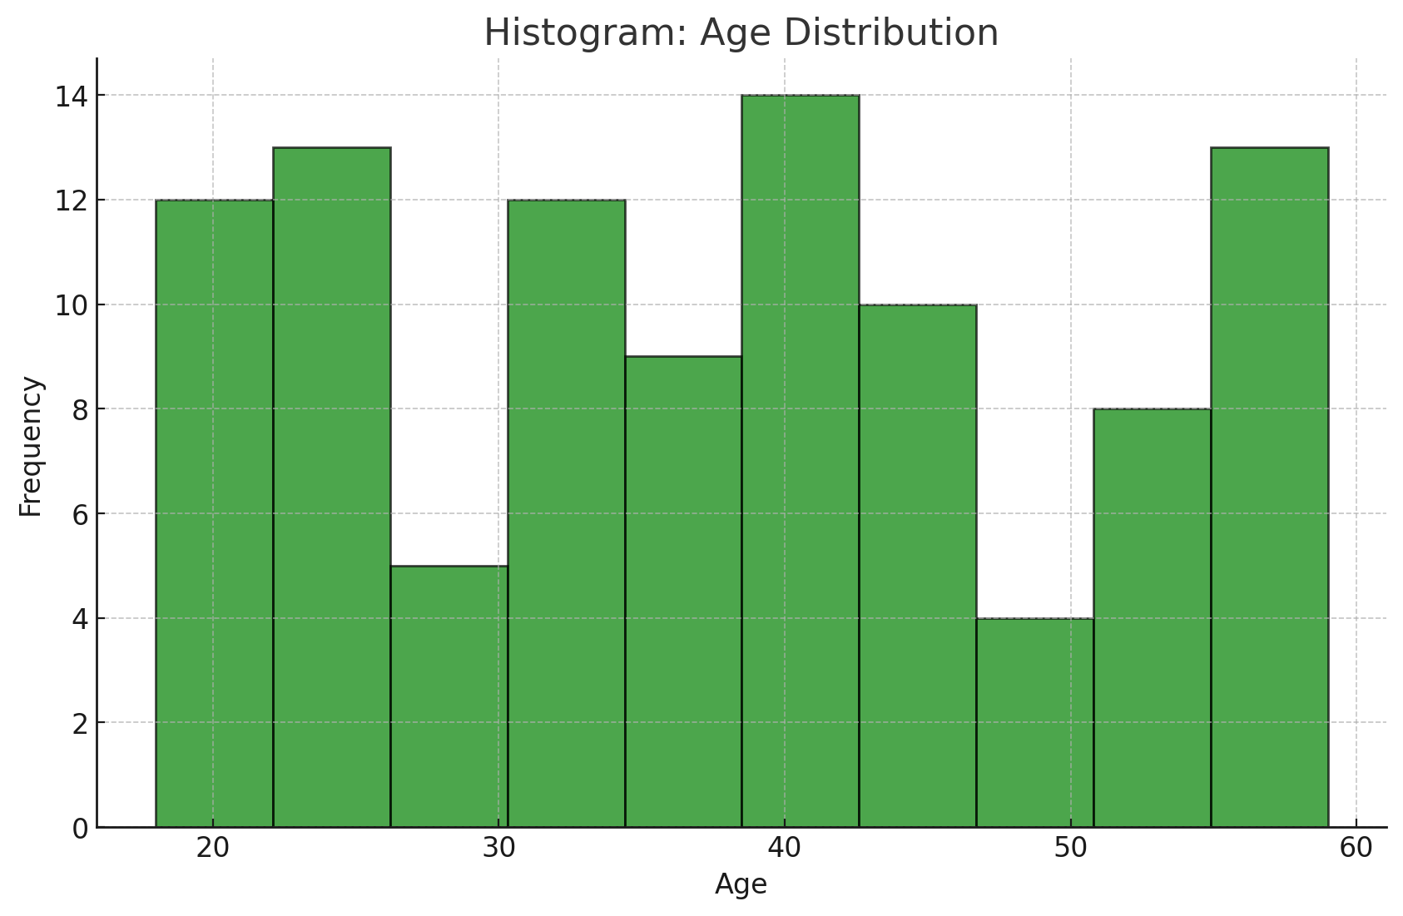

Here are the visualizations:

1. **Scatter Plot**: Shows the relationship between Age and Income. Each point represents an individual's data, with Age on the x-axis and Income on the y-axis.
2. **Histogram**: Displays the distribution of Ages in the dataset, grouped into bins. It helps visualize how the ages are spread across the dataset.

7. Write a python program to accept input from user and check whether number is Armstrong or not.

**Definition of an Armstrong Number:**

An **Armstrong number** (or narcissistic number) is a number that is equal to the sum of its own digits raised to the power of the number of digits. For example:

* 153=13+53+33153 = 1^3 + 5^3 + 3^3153=13+53+33 (3 digits)
* 9474=94+44+74+449474 = 9^4 + 4^4 + 7^4 + 4^49474=94+44+74+44 (4 digits)

def is_armstrong_number(num):

# Convert the number to a string to get digits

digits = str(num)

num_digits = len(digits)

# Calculate the sum of digits raised to the power of num_digits

armstrong_sum = sum(int(digit) ** num_digits for digit in digits)

# Check if the number is an Armstrong number

return armstrong_sum == num

# Input number from the user

number = int(input("Enter a number: "))

# Check and display result

if is_armstrong_number(number):

print(f"{number} is an Armstrong number.")

else:

print(f"{number} is not an Armstrong number.")

8. Implement Classification algorithm KNN classifier Data Analysis on given iris dataset.

The K-Nearest Neighbors (KNN) algorithm is a simple, supervised machine learning algorithm commonly used for classification. Below is an implementation of KNN for the Iris dataset using Python.

Steps to Implement KNN Classifier on Iris Dataset:

Load the Dataset:

Use the Iris dataset from sklearn.datasets.

Preprocess the Data:

Split the dataset into training and testing sets.

Standardize the features for better performance.

Implement the KNN Algorithm:

Use KNeighborsClassifier from sklearn.neighbors.

Evaluate the Model:

Measure the accuracy using the test set.

from sklearn.datasets import load_iris

from sklearn.model_selection import train_test_split

from sklearn.preprocessing import StandardScaler

from sklearn.neighbors import KNeighborsClassifier

from sklearn.metrics import accuracy_score, classification_report

import pandas as pd

# Load the Iris dataset

iris = load_iris()

X = iris.data # Features (Sepal Length, Sepal Width, Petal Length, Petal Width)

y = iris.target # Target labels (Setosa, Versicolor, Virginica)

# Split the dataset into training and testing sets (80% train, 20% test)

X_train, X_test, y_train, y_test = train_test_split(X, y, test_size=0.2, random_state=42)

# Standardize the features for better performance

scaler = StandardScaler()

X_train = scaler.fit_transform(X_train)

X_test = scaler.transform(X_test)

# Initialize the KNN classifier with k=3

knn = KNeighborsClassifier(n_neighbors=3)

# Train the model

knn.fit(X_train, y_train)

# Predict on the test set

y_pred = knn.predict(X_test)

# Evaluate the model

accuracy = accuracy_score(y_test, y_pred)

print(f"Accuracy of KNN Classifier: {accuracy:.2f}\n")

# Detailed classification report

print("Classification Report:")

print(classification_report(y_test, y_pred, target_names=iris.target_names))

9. Implement Classification algorithm Decision tree Data Analysis on given iris dataset.

from sklearn.datasets import load_iris

from sklearn.model_selection import train_test_split

from sklearn.tree import DecisionTreeClassifier, plot_tree

from sklearn.metrics import accuracy_score, classification_report

import matplotlib.pyplot as plt

# Load the Iris dataset

iris = load_iris()

X = iris.data # Features (Sepal Length, Sepal Width, Petal Length, Petal Width)

y = iris.target # Target labels (Setosa, Versicolor, Virginica)

# Split the dataset into training and testing sets (80% train, 20% test)

X_train, X_test, y_train, y_test = train_test_split(X, y, test_size=0.2, random_state=42)

# Initialize the Decision Tree Classifier

dt_classifier = DecisionTreeClassifier(random_state=42)

# Train the model

dt_classifier.fit(X_train, y_train)

# Predict on the test set

y_pred = dt_classifier.predict(X_test)

# Evaluate the model

accuracy = accuracy_score(y_test, y_pred)

print(f"Accuracy of Decision Tree Classifier: {accuracy:.2f}\n")

# Detailed classification report

print("Classification Report:")

print(classification_report(y_test, y_pred, target_names=iris.target_names))

# Visualize the Decision Tree

plt.figure(figsize=(12, 8))

plot_tree(dt_classifier, feature_names=iris.feature_names, class_names=iris.target_names, filled=True)

plt.title("Decision Tree Visualization", fontsize=16)

plt.show()

10. Write a Python program to print factorial of number using Recursion.

def factorial(n):

# Base case: if n is 0 or 1, return 1

if n == 0 or n == 1:

return 1

else:

# Recursive case: n * factorial(n-1)

return n * factorial(n - 1)

# Input number from user

num = int(input("Enter a number: "))

# Ensure the number is non-negative

if num < 0:

print("Factorial does not exist for negative numbers.")

else:

# Calculate and display the factorial

result = factorial(num)

print(f"Factorial of {num} is {result}")

11. Implement Data Visualization Kindly refers “income.csv” dataset.

1. Draw a scatter plot for Age and Income.

2. Draw a bar graph for Age and Income.

import pandas as pd

import matplotlib.pyplot as plt

# Load the dataset (Replace 'income.csv' with the path to your dataset)

data = pd.read_csv('income.csv')

# Check the first few rows of the dataset to ensure it's loaded correctly

print(data.head())

# 1. Scatter Plot: Age vs Income

plt.figure(figsize=(10, 6))

plt.scatter(data['Age'], data['Income'], color='blue', alpha=0.6)

plt.title('Scatter Plot: Age vs Income', fontsize=16)

plt.xlabel('Age', fontsize=12)

plt.ylabel('Income', fontsize=12)

plt.grid(True)

plt.show()

# 2. Bar Graph: Age vs Income (Bar plot)

plt.figure(figsize=(10, 6))

plt.bar(data['Age'], data['Income'], color='green', alpha=0.6)

plt.title('Bar Graph: Age vs Income', fontsize=16)

plt.xlabel('Age', fontsize=12)

plt.ylabel('Income', fontsize=12)

plt.xticks(rotation=45)

plt.show()

12. Implement clustering algorithm on given “income.csv” dataset and display it using scatter plot on given iris dataset.

import pandas as pd

import numpy as np

from sklearn.cluster import KMeans

from sklearn.preprocessing import StandardScaler

import matplotlib.pyplot as plt

# Load the income.csv dataset

data = pd.read_csv("income.csv")

# Inspect the dataset

print(data.head())

# Assuming the dataset has 'Age' and 'Income' columns, we use them for clustering

X = data[['Age', 'Income']]

# Handle missing values (if any) by dropping rows with missing values

X = X.dropna()

# Standardize the data (important for K-Means)

scaler = StandardScaler()

X_scaled = scaler.fit_transform(X)

# Apply KMeans clustering (let's choose 3 clusters for this example)

kmeans = KMeans(n_clusters=3, random_state=42)

data['Cluster'] = kmeans.fit_predict(X_scaled)

# Plotting the clusters using scatter plot

plt.figure(figsize=(10, 6))

# Scatter plot for Age vs Income with different colors for each cluster

plt.scatter(data['Age'], data['Income'], c=data['Cluster'], cmap='viridis', s=50)

plt.title('K-Means Clustering: Age vs Income', fontsize=16)

plt.xlabel('Age', fontsize=12)

plt.ylabel('Income', fontsize=12)

plt.colorbar(label='Cluster') # Show color legend for clusters

plt.show()

13. Write a python program to count the occurrence of each word in a given sentence

from collections import Counter

def count_word_occurrences(sentence):

# Split the sentence into words (using space as delimiter)

words = sentence.split()

# Count occurrences of each word using Counter

word_count = Counter(words)

return word_count

# Input sentence from the user

sentence = input("Enter a sentence: ")

# Get the word count

word_occurrences = count_word_occurrences(sentence)

# Display the word occurrences

print("Word occurrences:")

for word, count in word_occurrences.items():

print(f"'{word}': {count}")

14. Implement Classification algorithm SVM Classifier Data Analysis on given iris dataset.

from sklearn.datasets import load_iris

from sklearn.model_selection import train_test_split

from sklearn.svm import SVC

from sklearn.metrics import accuracy_score, classification_report

import matplotlib.pyplot as plt

# Load the Iris dataset

iris = load_iris()

X = iris.data # Features (sepal length, sepal width, petal length, petal width)

y = iris.target # Target labels (Setosa, Versicolor, Virginica)

# Split the dataset into training and testing sets (80% train, 20% test)

X_train, X_test, y_train, y_test = train_test_split(X, y, test_size=0.2, random_state=42)

# Initialize the SVM Classifier

svm_classifier = SVC(kernel='linear', random_state=42) # Linear kernel for simplicity

# Train the model

svm_classifier.fit(X_train, y_train)

# Predict on the test set

y_pred = svm_classifier.predict(X_test)

# Evaluate the model

accuracy = accuracy_score(y_test, y_pred)

print(f"Accuracy of SVM Classifier: {accuracy:.2f}\n")

# Detailed classification report

print("Classification Report:")

print(classification_report(y_test, y_pred, target_names=iris.target_names))

# Optional: Visualizing the decision boundaries for the first two features

# We'll use only the first two features for 2D visualization

X_train_2d = X_train[:, :2]

X_test_2d = X_test[:, :2]

# Train the SVM Classifier again with only 2 features for visualization

svm_classifier.fit(X_train_2d, y_train)

# Plotting the decision boundary

h = .02 # Step size in the mesh

x_min, x_max = X_train_2d[:, 0].min() - 1, X_train_2d[:, 0].max() + 1

y_min, y_max = X_train_2d[:, 1].min() - 1, X_train_2d[:, 1].max() + 1

xx, yy = np.meshgrid(np.arange(x_min, x_max, h), np.arange(y_min, y_max, h))

Z = svm_classifier.predict(np.c_[xx.ravel(), yy.ravel()])

Z = Z.reshape(xx.shape)

# Plot the decision boundary

plt.contourf(xx, yy, Z, alpha=0.8)

plt.scatter(X_train_2d[:, 0], X_train_2d[:, 1], c=y_train, edgecolors='k', marker='o', cmap=plt.cm.coolwarm)

plt.title("SVM Decision Boundary (First Two Features)")

plt.xlabel('Sepal Length')

plt.ylabel('Sepal Width')

plt.show()

15. Write a program to print length of String using Recursion.

def string_length(s):

# Base case: if the string is empty, return 0

if s == "":

return 0

else:

# Recursive case: 1 + length of the substring excluding the first character

return 1 + string_length(s[1:])

# Input string from the user

input_string = input("Enter a string: ")

# Call the function to get the length of the string

length = string_length(input_string)

# Print the length of the string

print(f"The length of the string is: {length}")

16. Implement clustering algorithm on given “income.csv” dataset and display it using scatter plot on given iris dataset.

import pandas as pd

import numpy as np

from sklearn.cluster import KMeans

from sklearn.datasets import load_iris

import matplotlib.pyplot as plt

# Load the income.csv dataset (Replace with the actual file path)

income_data = pd.read_csv("income.csv")

# Inspect the first few rows of the dataset

print(income_data.head())

# Assuming the dataset has 'Age' and 'Income' columns

X_income = income_data[['Age', 'Income']]

# Standardize the data (optional but recommended for K-Means)

from sklearn.preprocessing import StandardScaler

scaler = StandardScaler()

X_scaled = scaler.fit_transform(X_income)

# Apply K-Means clustering (let's choose 3 clusters for this example)

kmeans = KMeans(n_clusters=3, random_state=42)

income_data['Cluster'] = kmeans.fit_predict(X_scaled)

# Load the Iris dataset for visualization

iris = load_iris()

X_iris = iris.data[:, :2] # Using only the first two features: Sepal Length and Sepal Width

y_iris = iris.target # Target labels for the Iris dataset

# Visualize the clusters (we will plot the clusters using the first two features of Iris dataset)

plt.figure(figsize=(10, 6))

# Scatter plot for Iris data (for the first two features)

plt.scatter(X_iris[:, 0], X_iris[:, 1], c=income_data['Cluster'], cmap='viridis', edgecolor='k', s=50)

plt.title('K-Means Clustering on Income Data Visualized with Iris Dataset', fontsize=14)

plt.xlabel('Sepal Length')

plt.ylabel('Sepal Width')

plt.colorbar(label='Cluster')

plt.show()

17. Write a python program to print prime number between 1 to 100.

def is_prime(num):

# Check if a number is prime

if num <= 1:

return False

for i in range(2, int(num ** 0.5) + 1): # Loop up to the square root of the number

if num % i == 0:

return False

return True

# Print prime numbers between 1 and 100

print("Prime numbers between 1 and 100 are:")

for num in range(1, 101):

if is_prime(num):

print(num, end=" ")

18. Implement Classification algorithm Decision Tree Classifier Data Analysis on given iris dataset

from sklearn.datasets import load_iris

from sklearn.model_selection import train_test_split

from sklearn.tree import DecisionTreeClassifier

from sklearn.metrics import accuracy_score, classification_report

from sklearn import tree

import matplotlib.pyplot as plt

# Load the Iris dataset

iris = load_iris()

X = iris.data # Features (sepal length, sepal width, petal length, petal width)

y = iris.target # Target labels (Setosa, Versicolor, Virginica)

# Split the dataset into training and testing sets (80% train, 20% test)

X_train, X_test, y_train, y_test = train_test_split(X, y, test_size=0.2, random_state=42)

# Initialize the Decision Tree Classifier

dt_classifier = DecisionTreeClassifier(random_state=42)

# Train the model

dt_classifier.fit(X_train, y_train)

# Predict on the test set

y_pred = dt_classifier.predict(X_test)

# Evaluate the model

accuracy = accuracy_score(y_test, y_pred)

print(f"Accuracy of Decision Tree Classifier: {accuracy:.2f}\n")

# Detailed classification report

print("Classification Report:")

print(classification_report(y_test, y_pred, target_names=iris.target_names))

# Visualizing the Decision Tree

plt.figure(figsize=(12, 8))

tree.plot_tree(dt_classifier, filled=True, feature_names=iris.feature_names, class_names=iris.target_names, fontsize=10)

plt.title("Decision Tree Classifier on Iris Dataset")

plt.show()

19. Write a python program to Implement Data Visualization Kindly refers your own data.

1. Draw a horizontal bar graph.

2. Draw scatter plot diagram.

import matplotlib.pyplot as plt

import numpy as np

# Custom data for demonstration

categories = ['A', 'B', 'C', 'D', 'E']

values = [15, 30, 45, 10, 25]

# 1. Draw a horizontal bar graph

plt.figure(figsize=(10, 6))

plt.barh(categories, values, color='skyblue')

plt.xlabel('Values')

plt.ylabel('Categories')

plt.title('Horizontal Bar Graph')

plt.show()

# 2. Draw a scatter plot

# Let's create another custom dataset for scatter plot

x = np.array([1, 2, 3, 4, 5])

y = np.array([2, 3, 5, 7, 11])

plt.figure(figsize=(8, 6))

plt.scatter(x, y, color='red', marker='o')

plt.xlabel('X-axis')

plt.ylabel('Y-axis')

plt.title('Scatter Plot')

plt.grid(True)

plt.show()

20. Implement clustering algorithm on given “income.csv” dataset and display it using scatter plot on given iris dataset

import pandas as pd

import numpy as np

from sklearn.cluster import KMeans

from sklearn.datasets import load_iris

import matplotlib.pyplot as plt

from sklearn.preprocessing import StandardScaler

# Load the 'income.csv' dataset

# (replace 'income.csv' with the actual path to the file)

income_data = pd.read_csv("income.csv")

# Inspect the first few rows of the dataset

print(income_data.head())

# Assuming 'Age' and 'Income' are columns in the income dataset

X_income = income_data[['Age', 'Income']] # Select features for clustering

# Standardize the data (important for K-Means)

scaler = StandardScaler()

X_scaled = scaler.fit_transform(X_income)

# Apply K-Means clustering (let's choose 3 clusters for this example)

kmeans = KMeans(n_clusters=3, random_state=42)

income_data['Cluster'] = kmeans.fit_predict(X_scaled)

# Load the Iris dataset for visualization

iris = load_iris()

X_iris = iris.data[:, :2] # Using only the first two features: Sepal Length and Sepal Width

y_iris = iris.target # Target labels for the Iris dataset

# Visualize the clusters (we will plot the clusters using the first two features of the Iris dataset)

plt.figure(figsize=(10, 6))

# Scatter plot for Iris data (for the first two features)

plt.scatter(X_iris[:, 0], X_iris[:, 1], c=income_data['Cluster'], cmap='viridis', edgecolor='k', s=50)

# Adding plot title and labels

plt.title('K-Means Clustering on Income Data Visualized Using Iris Dataset', fontsize=14)

plt.xlabel('Sepal Length')

plt.ylabel('Sepal Width')

plt.colorbar(label='Cluster')

plt.show()

21. Implement Data Visualization Kindly refers “Salary_Data.csv” dataset.

1. Draw a Scatter plot for Age and Salary.

2. Draw Histogram for Salary.

import pandas as pd

import matplotlib.pyplot as plt

# Load the "Salary_Data.csv" dataset

# Replace 'Salary_Data.csv' with the actual path to your CSV file

salary_data = pd.read_csv("Salary_Data.csv")

# Inspect the first few rows of the dataset to ensure it contains 'Age' and 'Salary'

print(salary_data.head())

# 1. Scatter plot for Age and Salary

plt.figure(figsize=(10, 6))

plt.scatter(salary_data['Age'], salary_data['Salary'], color='b', edgecolor='k', alpha=0.7)

plt.title('Scatter Plot of Age vs Salary', fontsize=14)

plt.xlabel('Age')

plt.ylabel('Salary')

plt.grid(True)

plt.show()

# 2. Histogram for Salary

plt.figure(figsize=(10, 6))

plt.hist(salary_data['Salary'], bins=10, color='skyblue', edgecolor='black', alpha=0.7)

plt.title('Histogram of Salary', fontsize=14)

plt.xlabel('Salary')

plt.ylabel('Frequency')

plt.grid(True)

plt.show()

22. Write a Python program to print factorial of number using Recursion.

# Function to calculate factorial using recursion

def factorial(n):

# Base case: factorial of 0 or 1 is 1

if n == 0 or n == 1:

return 1

# Recursive case: n * factorial of (n-1)

else:

return n * factorial(n - 1)

# Accept user input

number = int(input("Enter a number to find its factorial: "))

# Call the recursive function and display the result

result = factorial(number)

print(f"The factorial of {number} is {result}")

23. Write python program to accept number and check whether number is Armstrong or not.

# Function to check whether the number is Armstrong or not

def is_armstrong(num):

# Convert the number to string to easily get digits

num_str = str(num)

num_digits = len(num_str) # Number of digits in the number

# Calculate the sum of each digit raised to the power of number of digits

sum_of_powers = sum(int(digit) ** num_digits for digit in num_str)

# Check if the sum equals the original number

if sum_of_powers == num:

return True

else:

return False

# Accept user input

number = int(input("Enter a number to check if it is Armstrong: "))

# Check and print the result

if is_armstrong(number):

print(f"{number} is an Armstrong number.")

else:

print(f"{number} is not an Armstrong number.")

24. Write a Python program to print factorial of number using Recursion.

# Function to calculate factorial using recursion

def factorial(n):

# Base case: if n is 0 or 1, return 1

if n == 0 or n == 1:

return 1

# Recursive case: n * factorial of (n-1)

else:

return n * factorial(n - 1)

# Accept user input

number = int(input("Enter a number to find its factorial: "))

# Call the recursive function and display the result

result = factorial(number)

print(f"The factorial of {number} is {result}")

25. Implement clustering algorithm on given “income.csv” dataset and display it using scatter plot on given iris dataset.

import pandas as pd

import numpy as np

from sklearn.cluster import KMeans

from sklearn.datasets import load_iris

import matplotlib.pyplot as plt

from sklearn.preprocessing import StandardScaler

# Load the 'income.csv' dataset

# Make sure to replace 'income.csv' with the correct path to your CSV file

income_data = pd.read_csv('income.csv')

# Inspect the first few rows of the dataset to ensure it contains 'Age' and 'Income'

print(income_data.head())

# Assuming the columns in income.csv are 'Age' and 'Income' for clustering

X_income = income_data[['Age', 'Income']]

# Standardize the data (important for K-Means)

scaler = StandardScaler()

X_scaled = scaler.fit_transform(X_income)

# Apply K-Means clustering (let's choose 3 clusters for this example)

kmeans = KMeans(n_clusters=3, random_state=42)

income_data['Cluster'] = kmeans.fit_predict(X_scaled)

# Load the Iris dataset for visualization

iris = load_iris()

X_iris = iris.data[:, :2] # Using only the first two features: Sepal Length and Sepal Width

y_iris = iris.target # Target labels for the Iris dataset

# Visualize the clusters (we will plot the clusters using the first two features of the Iris dataset)

plt.figure(figsize=(10, 6))

# Scatter plot for Iris data (for the first two features)

plt.scatter(X_iris[:, 0], X_iris[:, 1], c=income_data['Cluster'], cmap='viridis', edgecolor='k', s=50)

# Adding plot title and labels

plt.title('K-Means Clustering on Income Data Visualized Using Iris Dataset', fontsize=14)

plt.xlabel('Sepal Length')

plt.ylabel('Sepal Width')

plt.colorbar(label='Cluster')

plt.show()